How to Install Zabbix Server and Agent in CentOS

Step 1: Need to Disable “Selinux”.
Open SELinux configuration and edit the file:

vim /etc/sysconfig/selinux
Change “SELINUX=enforcing” to “SELINUX=disabled”

then reboot the server.

Step 2: Install and configure Apache (WEB Server for Zabbix)

yum -y install httpd
systemctl status httpd.service
systemctl start httpd.service
systemctl enable httpd (Symbolic link which is used to auto restart the httpd after reboot the server)

Step 3: Needed Reporsitories for PHP 7 Installation (This PHP required to show the Zabbix Web)

yum -y install epel-release
sudo rpm -Uvh https://mirror.webtatic.com/yum/el7/webtatic-release.rpm

yum -y install mod_php72w php72w-cli php72w-common php72w-devel php72w-pear php72w-gd php72w-mbstring php72w-mysql php72w-xml php72w-bcmath

And after the installation is complete, we need to edit the default 'php.ini' file using the vim editor.

vim /etc/php.ini

Change the values of the configuration as shown below.

max_execution_time = 600
max_input_time = 600
memory_limit = 256M
post_max_size = 32M
upload_max_filesize = 16M
date.timezone = Asia/Jakarta (you could set any time zone and it must required to install zabbix web)

Now restart the httpd service.

systemctl restart httpd

Step 4: Need to install Maria-DB Server.

sudo yum -y install mariadb-server

After the installation is complete, start the service and enable it to launch everytime at system boot.
systemctl start mariadb
systemctl enable mariadb
Now run the command below to configure MariaDB root password.

mysql_secure_installation

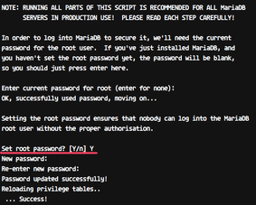
** you must need to save this password for next login to Maria-DB by below query:
mysql -u root -p

Now we will create database for Zabbix Server.

create database zabbix;
grant all privileges on zabbix.* to zabbix@'localhost' identified by 'mizan12345';

(**Here Zabbix is database and * means all tables !!! user zabbix needed to use Zabbix database from “localhost”)
grant all privileges on zabbix.* to zabbix@'%' identified by 'mizan12345';
flush privileges;

Step 5: Installation of Zabbix Server and Agent
Add the Zabbix repository to the CentOS 7 system.
rpm -Uvh https://repo.zabbix.com/zabbix/4.2/rhel/7/x86_64/zabbix-release-4.2-2.el7.noarch.rpm

Now install Zabbix using the yum command below.
yum -y install zabbix-get zabbix-server-mysql zabbix-web-mysql zabbix-agent

Step 6: Import the sample Database provided by Zabbix.

cd /usr/share/doc/zabbix-server-mysql-4.2.8
zcat create.sql.gz | mysql -u zabbix -p zabbix
zcat create.sql.gz | mysql -u (mysql_user) -p (Database_name)

now give the password which is you set early (mizan12345)

Step 7: Now Configure the Zabbix

vim /etc/zabbix/zabbix_server.conf

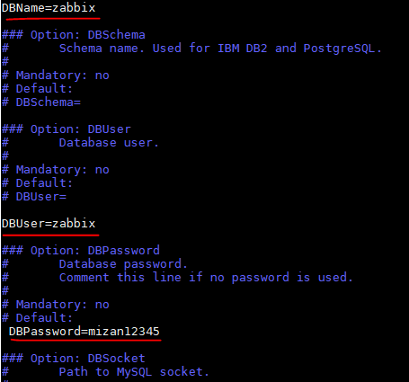
Save and exit. After that start the Zabbix-server service and enable it to launch everytime at system boot.
systemctl start zabbix-server
systemctl enable zabbix-server

To check the status run below command:
systemctl status zabbix-server

Step 8: Configure the Zabbix-Agent

Zabbix-agent must be installed on the target monitoring system. The agent will gather all information of the server and reports data to the Zabbix-server.
Edit the Zabbix-agent configuration file using vim.

vim /etc/zabbix/zabbix_agentd.conf

Change following lines with your own info:

Server=127.0.0.1
ServerActive=127.0.0.1
Hostname=localhost.localdomain

Save and exit.
Now start the zabbix-agent and enable it to launch everytime at system boot.
systemctl start zabbix-agent
systemctl enable zabbix-agent

Zabbix-agent is running on the system - check it using the following command.
systemctl status zabbix-agent

Step 9: Need to configure the firewalld
yum -y install firewalld
Start the firewalld service and enable it to launch everytime at system boot.

systemctl start firewalld
systemctl enable firewalld
Now we will open the HTTP and https port, and the port that will be used by the Zabbix-server and Zabbix agent (port 10051 and 10050).
Run the following firewall-cmd commands.
firewall-cmd --add-service={http,https} --permanent
firewall-cmd --add-port={10051/tcp,10050/tcp} --permanent

Now reload the firewalld configuration and check the port.
firewall-cmd --reload
firewall-cmd --list-all

Now restart all the services yet again.
systemctl restart zabbix-server
systemctl restart zabbix-agent
systemctl restart httpd

Zabbix Web Initial Setup:

Now open your web browser, and type your server IP address.

http://your_IP/zabbix

And you will be redirected to the Zabbix welcome message.

Click the 'Next Step' button.
Now, Zabbix will check all system requirements for its installation. Make sure there is no error.
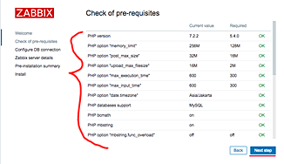

Then click the 'Next step' button again.
For the database info, type all your database setup.
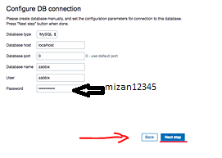
And click the 'Next step' button.
Now comes the Zabbix server details configuration. On the 'Host' field, type your own server IP address, and change the name with your own domain name or hostname.
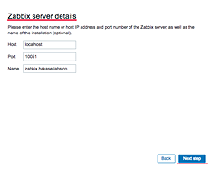
Click the 'Next step' button again.
Make sure all of those configurations are correct, then click the next button to install Zabbix.
And when the installation is complete, you will get the page as shown below.
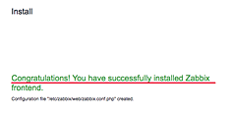
Click the 'Finish' button and you will be redirected to the Zabbix login page.
Login with default user 'Admin' and Password 'zabbix'.
Now you get the Zabbix admin Dashboard.
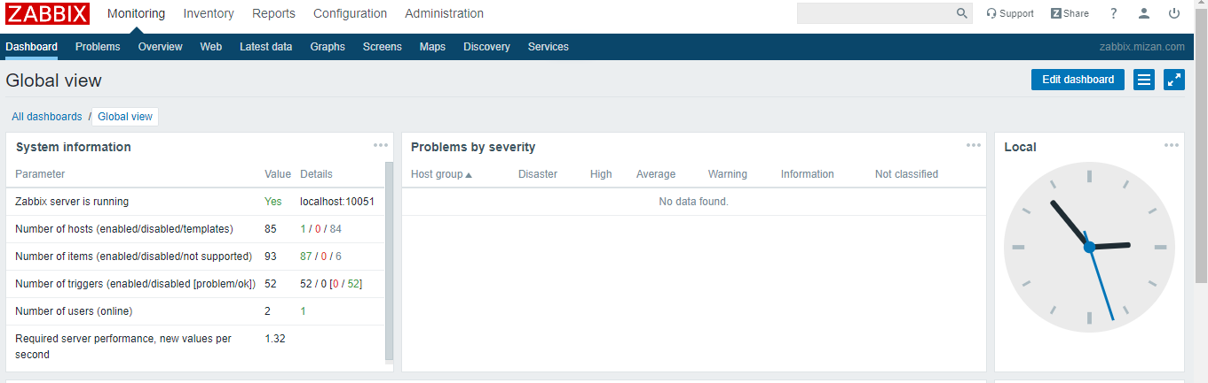
Prepared by Mizan

